* Create a public GitHub repository for your "Hello World"

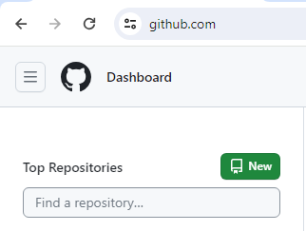

* In your repository, create a simple "Hello World" in Python print ("Hello, World!")

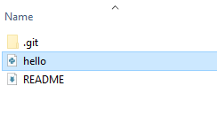

* In your repository, create a. GitHub/workflows directory File name as Deploy.yml name: Deploy Hello World

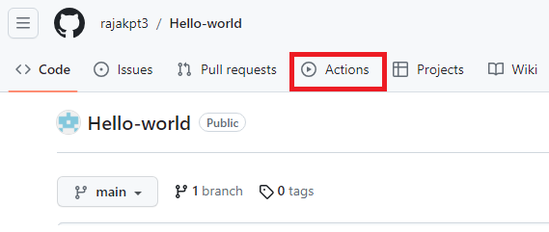

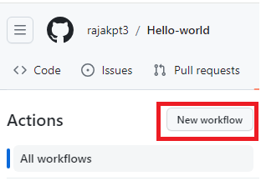

on:

push:

branches:

- main

jobs:

deploy:

runs-on: ubuntu-latest

steps:

- name: Checkout code

uses: actions/checkout@v2

- name: Set up Python

uses: actions/setup-python@v2

with:

python-version: '3.8'

- name: Run Hello World

run: python hello.py

Commit and push the deploy.yml file to your repository.

* You can monitor the status of your workflow by going to the "Actions" tab in your GitHub repository. You'll see the workflow running, and you can view logs to ensure your "Hello World" app runs successfully.

